CTF Topic: Injecting JavaScript with JS Injector Firefox Extension

Introduction

JS Injector is a Firefox extension that allows users to inject custom JavaScript into any webpage. This can be useful for testing, debugging, and manipulating web pages in real-time.

Tools and Requirements

- Mozilla Firefox browser  
- Install the [JS Injector Firefox extension](<https://addons.mozilla.org/en-US/firefox/addon/js-injector/?utm_source=addons.mozilla.org&utm_medium=referral&utm_content=search> )  
- Basic understanding of JavaScript and web development

Scenario

As a participant in this CTF challenge, your task is to use the JS Injector Firefox extension to inject JavaScript into `http://testphp.vulnweb.com/`. Perform the injections and answer the following questions based on your findings.

Begin

1. Install the JS Injector Firefox extension from the provided link.  
2. Visit `http://testphp.vulnweb.com/` and use the extension to inject the given JavaScript code snippets.  
3. Observe the changes or outputs produced by the injections to answer the questions.

Questions and Answers

Flag 1: Use JS Injector to inject the following JavaScript code to change the background color of the webpage to blue. What is the JavaScript code?

Answer:

javascript  
document.body.style.backgroundColor = 'blue';

Flag Captured.

Flag 2: Inject JavaScript to display an alert with the message "CTF Challenge Completed!" on the webpage. What is the JavaScript code?

Answer:

javascript  
alert('CTF Challenge Completed!');

Flag Captured.

Flag 3: Use JS Injector to change the text content of the first `<h1>` element on the homepage to "Welcome to CTF". What is the JavaScript code?

Answer:

javascript  
document.querySelector('h1').textContent = 'Welcome to CTF';

Flag Captured.

Flag 4: Inject JavaScript to log the title of the webpage to the console. What is the JavaScript code?

Answer:

javascript  
console.log(document.title);

Flag Captured.

Flag 5: Use JS Injector to hide all images on the webpage. What is the JavaScript code?

Answer:

javascript  
document.querySelectorAll('img').forEach(img => img.style.display = 'none');

Flag Captured.

Flag 6: Inject JavaScript to add a new paragraph with the text "CTF Challenge is fun!" to the end of the webpage. What is the JavaScript code?

Answer:

javascript  
let p = document.createElement('p');  
p.textContent = 'CTF Challenge is fun!';  
document.body.appendChild(p);

Flag Captured.

Hint

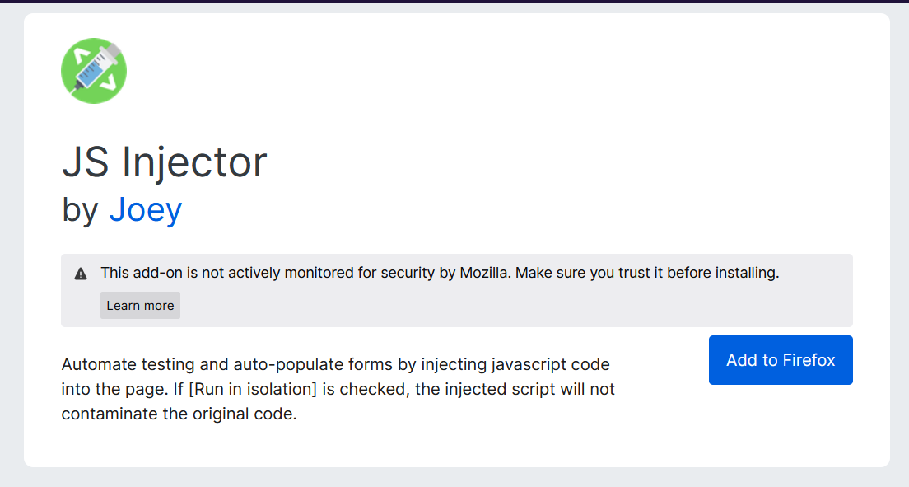

Install the JS Injector Firefox extension and use it to inject the provided JavaScript code snippets into `http://testphp.vulnweb.com/`. Observe the changes on the webpage to answer the questions accurately.